Programming and Compact for the New LDP 9208D/9224D/F & 9240D.

Sennehiser:

LDP 9208D/9224D/F & 9240D - NO EHS for all models ONLY HSL10 II Lifter.

Plantronics & Jabra

LDP 9208D = NO EHS only Lifter – HL10 (Plantronics) or GN1000 (Jabra)

LDP 9224D/F & 9204D = EHSA - looks the same as an LIP EHS just on the bracket.

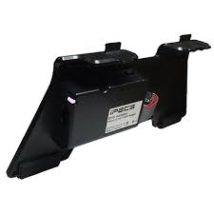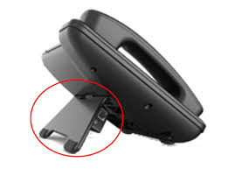
The phone programming that needs to be done on the phones are as below:
1. Press the Transfer (Trans) Key and then the numbers 19 and then select 1 for Ear Mic - Mic Headset ON – press Hold to save.

2. Press the Transfer (Trans) Key and then the numbers 61 and select 1 - Speaker (do not do 0 for headset) - press Hold to save.

3. . Press the Transfer (Trans) Key and then the numbers 62 and select 3 for Both - press Hold to save.
This will allow the sound to come through phone and headset.

