Sennheiser firmware update and battery reset process
Firmware Update
- Follow this link – https://www.eposaudio.com/en/au/enterprise/technology/software/epos-connect - scroll down to ‘Download EPOS CONNECT software’ and click on the 1st option to download it. Install the exe file.

- Once you have installed the program on your computer, you will then need to connect the device via USB to the computer and run the program. To do so, insert your thumbnail between the headset and the leatherette earpad (on the same side of the headset as the microphone boom arm) and remove, with the plastic ring to reveal the micro-USB port located underneath and then use a micro-USB to USB cable to connect it with your PC.
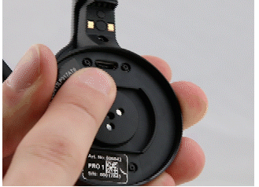
- When the MB Pro is connected via the micro-USB port to your PC you can open the program EPOS Connect app you will to see the MB Pro headset on the home page. It will display both the device ID and current firmware version on your device.
- Now simply go to the "Updates" tab, click the 'Update' button and the program will download the latest version and upload it to the device.
- If you have the accessory Bluetooth dongle BTD 800 USB follow this additional step.
When the update of your headset is complete, please disconnect it, connect your dongle, and then repeat the steps as above to also update the dongle.

Battery Reset
For an MB Pro or Pro UC headset

- Turn the headset off (hold the multifunction button for two seconds; this should be followed by the voice prompt "powering off" and the LED flashing red three times.
- Press and hold the multifunction button until the LED flashes alternately red and blue (this indicates that the device has entered pairing mode).
- Simultaneously press and hold the multifunction button and the audio button (volume control button) for five seconds until the LED flashes purple three times, and then re-enters pairing mode (indicated by the LED flashing alternately red and blue).
- The headset has been reset.

